Export Color PDF Combined— Supernote Plugin

A plugin for the Supernote NOTE and DOC apps that Exports colored pen strokes within documents to a PDF output. When viewed on a color screen, the colored strokes appear, even though they do not look colored when adding them via a Supernote.

Currently this plugin only works for NOTE and DOCs. Does not work for Digests.

To activate this plugin:

From either a NOTE or a DOC, click the Plugins Button, then choose “Export Color PDF”.

Choose from one of three options:

- Output All pages with annotations
- Output only new annotations – this outputs annotations that were added since the last export.
- Output the entire document. This can take a long time, especially for documents with 75+ pages. A page counter will let you know how far along you are.

Example output:

Notes:

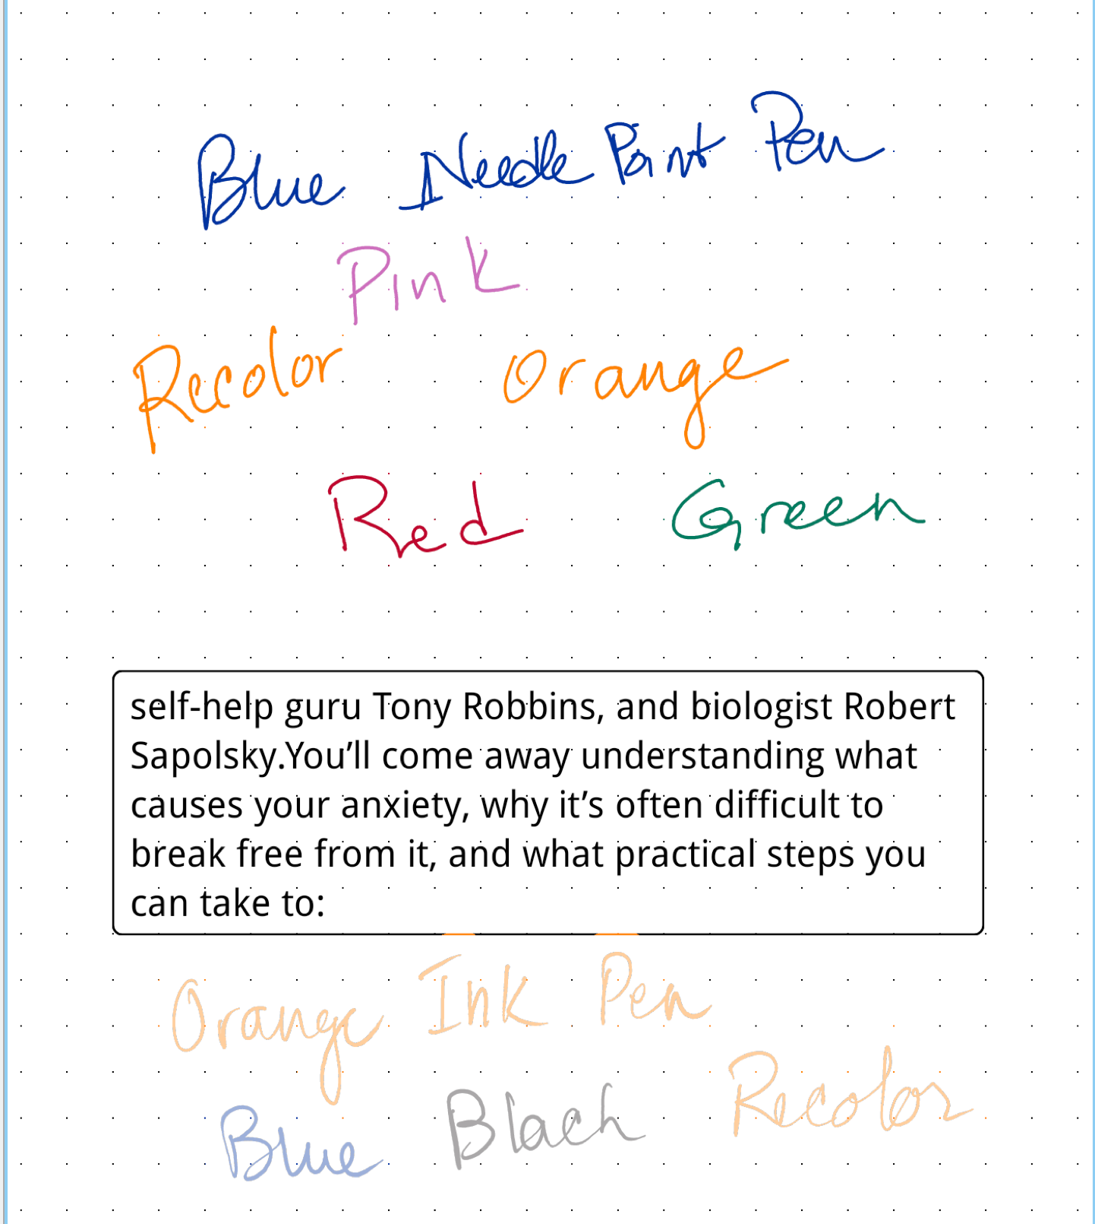
Doc:
Highlighter colors over the headings
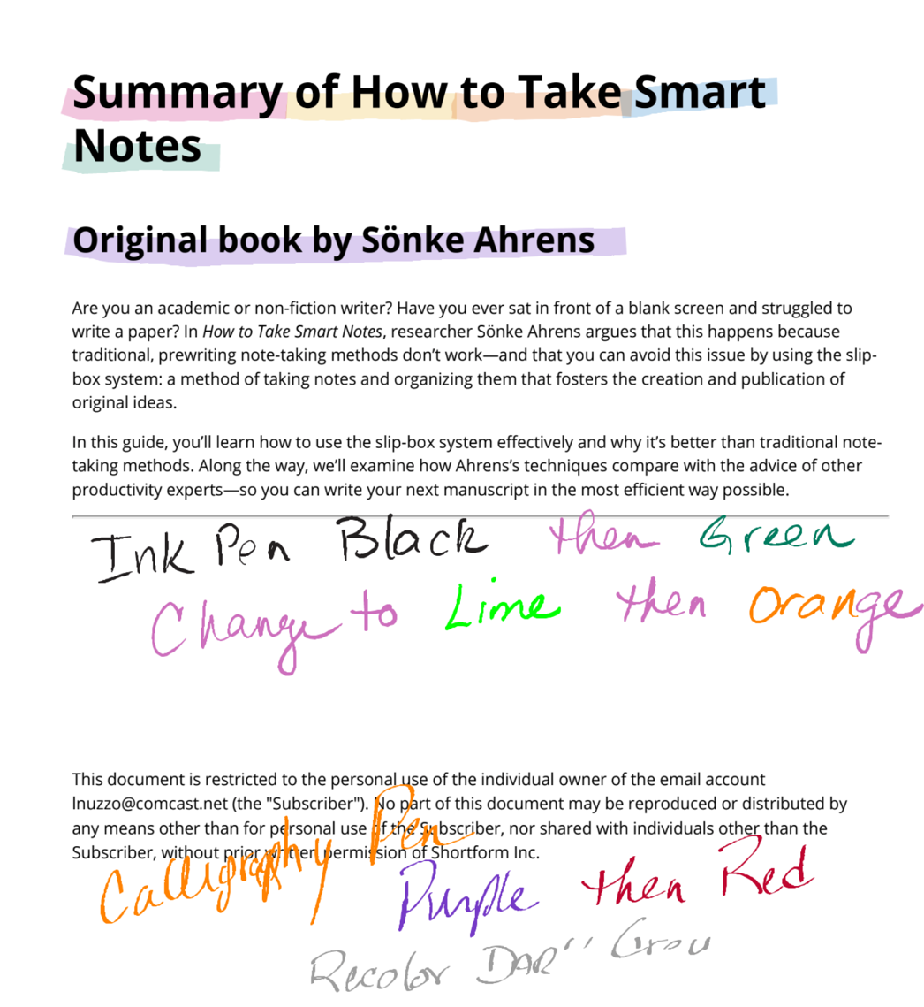
If you don’t completely choose the word with the lasso, only the letters chosen change color

Note with Marker:

